THE CLUBHOUSE
2-MAN BOX BLIND
ASSEMBLY INSTRUCTIONS
Note: It takes two (2) people to assemble the CLUBHOUSE Box Blind.
Hughes Products Company, Inc. assumes no liability for injury or damage to persons or property resulting from the use of the Hughes 2- Man Box Blind. The blind must be assembled, installed, anchored and used with care, caution and common sense. Anchoring the Hughes 2-Man Box Blind is the owner's responsibility.
YOU MUST READ ALL INSTRUCTIONS BEFORE STARTING ASSEMBLY!
TOOLS REQUIRED FOR ASSEMBLY:
Cordless drill Measuring tape
Phillips head bit Adjustable wrench or pliers
Square Wood cutting saw
Parts list:  (2) Roof (lap and overlap)  (6) Walls A, B, C(2) & D(2)  (l) Package w/screws, nuts and bolts  & hardware | WOOD ITEMS NEEDED  (2) 2 x 4 x 49-1/4" wall support #1  (2) 2 x 4 x 88-3/4" wall support #2  (2) 2 x 4 x 32 1/2" Top support  (2) 2 x 4 x 31-1/4" door post
Floor is not included: The Hughes 2-Man Box Blind requires a minimum platform of
48" x 95".
Assembly Instructions:
1. With wall panels A & C vertical, one person stands on the inside with nuts & the other on the outside with the screws(8-32 x ³/4) (see fig. I), Overlap the offset corner of panel A with panel C. Using the predrilled holes, starting at the top insert screws (8-32 x ³/4) one at a time down the edge of panel A. DO NOT PUT A SCREW IN THE 3RD HOLE UP FROM THE BOTTOM. BECAUSE A WOOD SCREW WILL GO THERE AT A LATER TIME
DURING ASSEMBLY. Make sure panels are tight against each other before you insert each screw.
2. Find panel D attach it to the opposite side of panel A (that you just assembled) forming a U shape with the 3 panels. Repeat the steps used in section 1 to attach panel D to A. Set this U-shape section to the side and now we are going to make another U shape section with the other 3 panels.
- Using panels B & C stand them vertical; again, one person stands on the inside and one on the outside. Attach the 2 panels together starting at the top working your way down the side.
Remember to skip the 3 ^{rd} hole from the bottom. Now find panel D and attach it to the opposite side of panel B making another U-shape with the 3 panels.
- Now slide the two U shaped sections (of 3 panels) together so that panel C overlaps panels D. The C section had predrilled holes that you will use as a template to drill the holes in Panel D. We recommend drilling one hole then inserting the bolt and nut starting at the top and working your way down. Again, leave that middle bolt out.
- Find the two roof panels; one will be marked top roof and the other bottom roof. The top must lay on top of the bottom roof to have proper assembly. This is important so that the holes line up correctly. Attach the two with the 8-32 x % screws and nuts starting in the middle and working your way to each side. Set this to the side for later use.
- Now it's time to insert the 2 x 4 wall support #1 on the inside of panel A in the channel horizontally just below the window (see fig. Il). From the outside of panel A use the #10 x 1 self-tapping screws in the predrilled holes to attach the 2 x 4 to the panel. Make sure the 2 x 4 pulls up tight to the panel. This step will be on one of the two 4 ft. ends.
- Repeat step 6 on the other end of the blind on panel B using the other 2 x 4 wall support
- Using 2 x 4 wall support #2 slide it into the channel of panel C & D ( this is your 8 ft. section on the blind) just below the window and attach with the #10 x 1 self-tapping screws. (It should butt into the sides of the 2 x 4 wall supports #1 that you previously done).
- Repeat step 8 on the other side on panels C & D.
- From the inside of the blind attach each 2 x 4 in the inside corner with the #8 x 3” wood screws. (see fig. lll)
11. Before you slide the plywood in, take out the 4 bolts and nuts in the bottom corners of the blind. You are now ready to slide the piece of plywood into the bottom of the blind so that it sits on the plastic lip around the inside of the blind. The corners will overlap around the plywood. Once this is done, you can put the bolts and nuts back in the holes that you just took out. (If using a thicker piece of plywood, you will have to drill new holes).
12. On the door cut out panel, insert the 2 x 4 x 31-1/4" door post on each side of the cut out and attach the 2 x 4 with screws going through the panel into the door post (2x4) Now screw the #8 x 3” wood screw into the top of wall support into the door post and up through the bottom of the floor into the door post to lock in the door frame (see fig. V).
13. On the inside of panel C you will see a groove going up beside the window opening. This is where you insert the 2x4 top support running vertically to the top of the blind. Attach with the 10 x 1 self-tapping screws.
14. Repeat step 13 on the other end of the blind on panel D across from the previous panel using the other 2x4 top support.
15. Next we are going to put the roof on top of the blind. Using a drill bit you will see the pre-drilled holes on the roof, use these as a template and drill through the blind walls and attach the roof to the walls using 8x32 bolts and nuts. ( Its easier to do the four corners first and then fill in the areas in between).

16. The last step to assemble your blind will be to insert your roof support provided to the (2) vertical top supports you installed and secure with the 10 x 1 pan head screws with washers provided. (Make sure that you have the metal support in the groove of the roof and pushing it up to make your ceiling height around 6 ft 3 inches).

If you would have any problems with this product, please contact Hughes Products Company at 336-769-3788. Please do not contact the merchant where you purchased the blind.

HUGHES PRODUCTS COMPANY, INC.
PO BOX 606
WALLBURG, NC 27363
336-769-3788 FAX-336-769-3792
Email: hughesproductsco@yahoo.com

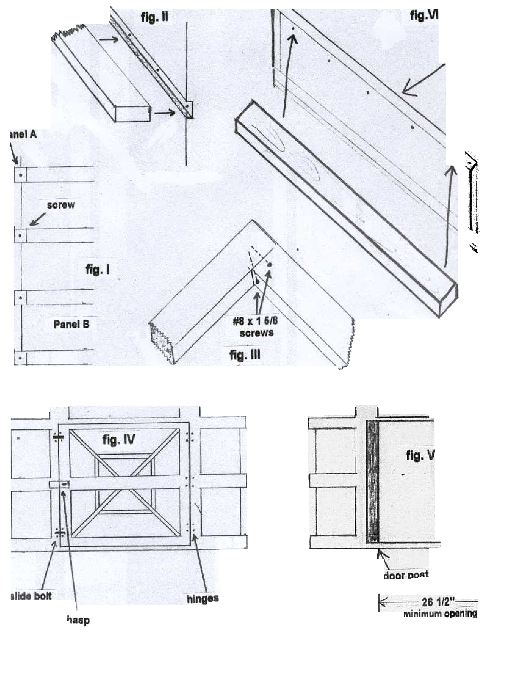
Hughes Products Company
Full Door Instructions
Prior to assembling the door make sure that you have already installed the floor, wall supports, and roof supports. Assembly is based on the floor being ½ inch thick piece of plywood.
Materials Needed
2 x 4 x 57 ½ (1)
2 x 3 x 57 ½ (1)
2 x 4 x 49 ½ (1)
Door Handle with screws and Keys (included)
10 x 1 Pan head screws and 3 inch wood screws (included)

- First put the Horizontal 2 x 4 x 49 ½ into the top of the blind (Right above the door cut out) using the 10 x 1 pan head screws through the plastic into the wood.
- Second place your Vertical 2 x 4 x 57 ½ on the right side of the door panel (Facing the blind from the outside) going from the floor to the horizontal piece previously installed in step 1. Using 10 x 1 pan head screws.
- Next place the other Vertical 2 x 3 x 57 ½ on the left side of the door panel ( Hinge side of door) going from the floor to the Horizontal piece previously installed in step 1. Using 10 x 1 pan head screws.
- Next using the 3 inch wood screws. Place these screws through the horizontal 2 x 4 x 49 ½ into the Vertical supports that are 57 ½ inch boards. Repeat this step as well for the floor into the 57 ½ inch boards.
- Now you are ready to attach your door into the wood frame using the 10 x 1 pan head screws. ( When installing the door make sure you have the door pulled up against the left vertical support tight and the upper horizontal support as well this way the door will fit snug. ( Hinge side is the left side)
- Next you will attach your door handle you will see pre-drilled hole on a metal plate on the door and hole through the plastic insert the metal rod through the large hole and Then using the small bolts and nuts attach them to the handle to secure it in place. Last attach the handle to the other end and tighten down with the wrench included.
- You then can place your weather stripping on the top of the metal frame and the right side of it to secure and weather tight seal. (rub metal down with alcohol before installing weather stripping. Also do not stretch this for it will not hold on the door. You will Need to cut the weather stripping to the desired length on the door.)

